# Results of the Experimentation

1.The following pie chart is showing the share of each activity in the dataset. The graph shows that sitting contains 18.69%, **lying** contains 19.14%,Walking Upstairs contains13.14 %, Walking downstairs contains 14.59%,Walking contains 16.68% and Standing contains 17.49%.

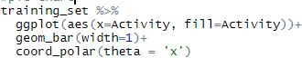

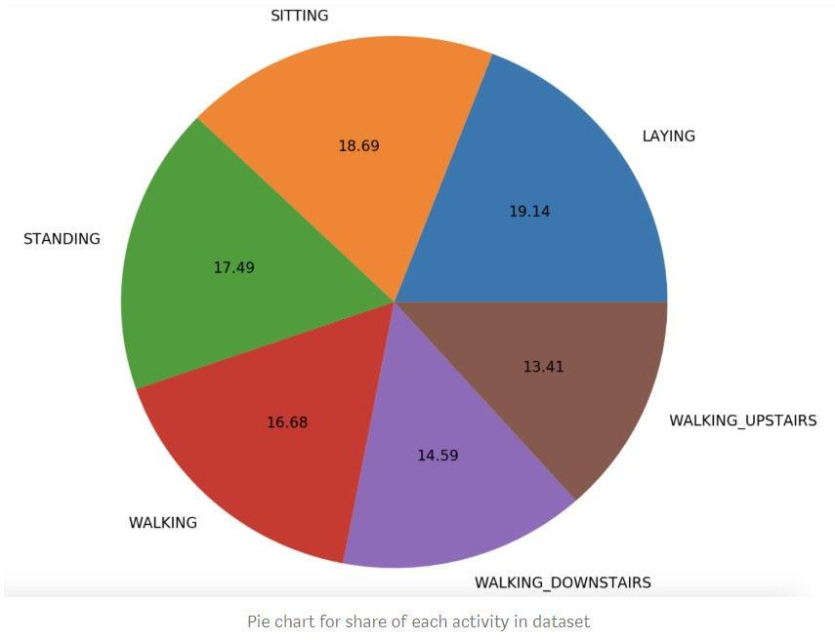

1. This graph depicts that when the angle of the sensor is on X-Axis with respect to gravity the person is **lying** down.

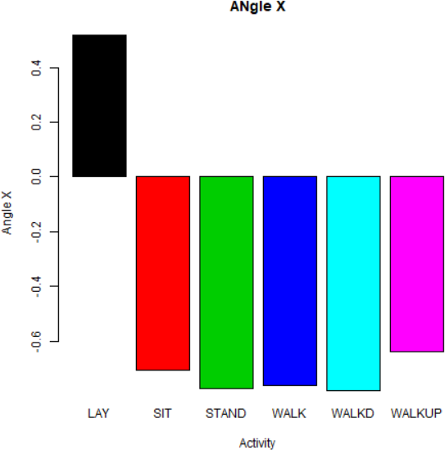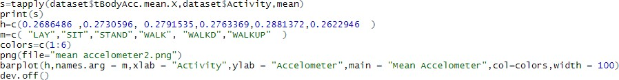

3 .This graph depicts that when the angle of the sensor is on Y-Axis with respect to gravity the person is not **lying** down. It also depicts a very low value of sitting which indicates the person is also not sitting.

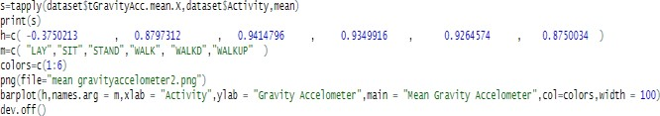

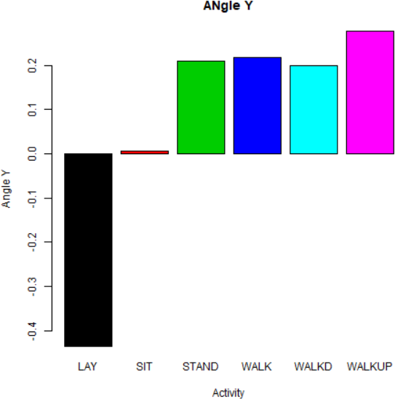

1. . This graph depicts that when the angle of the sensor is on Z-Axis with respect to gravity the person is not **lying** down as the value is increasing in negative magnitude.

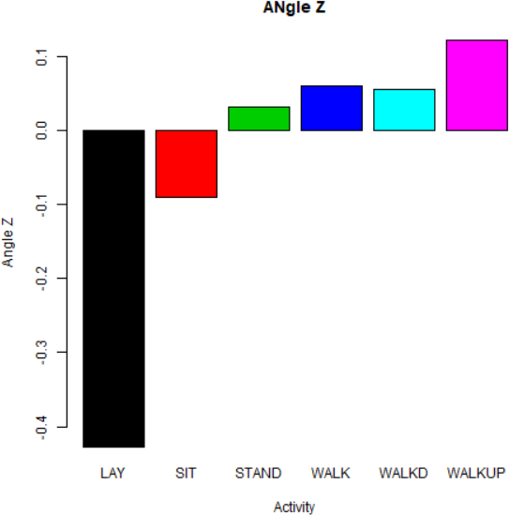

1. . The graph depicts that while Search Results is taking values the person may be in any of the positions.

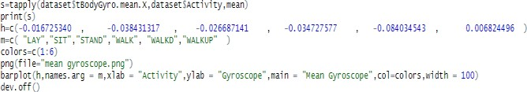

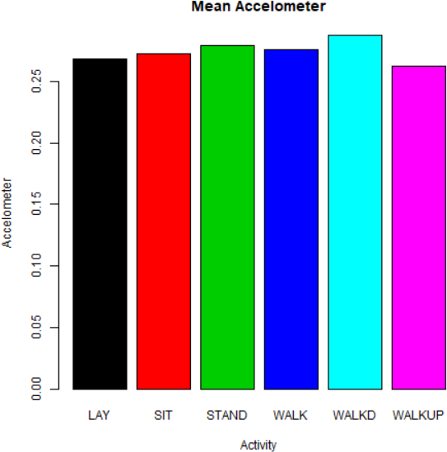

1. This graph depicts that when Body jerk is experienced with the accelometer person may be in any of the positions.

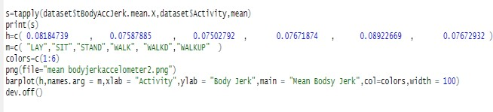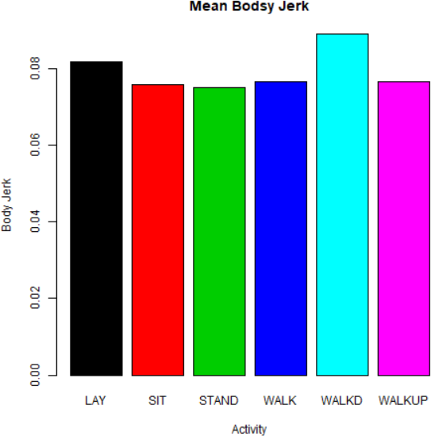

1. This graph shows that when the body magnet is directed towards a positive value the person is going downstairs. The person is definitely not **lying** down , sitting or standing when the mean body magnet value is increasing.

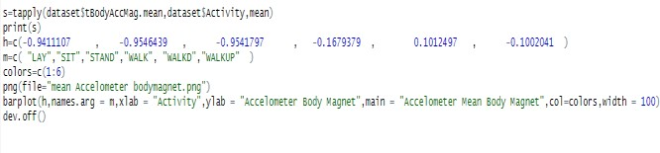

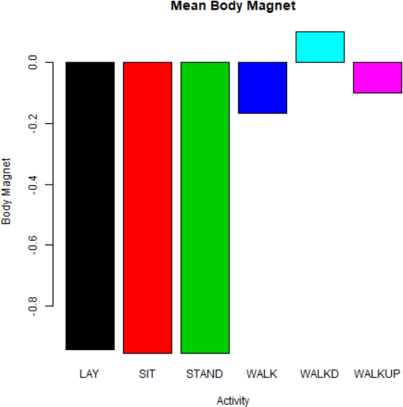

1. .This graph shows that when the values of mean gravity of accelometer is in negative , it states that the

person is lying down which is totally opposite to the conclusion using gyro sensor.

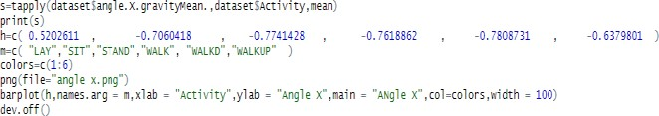

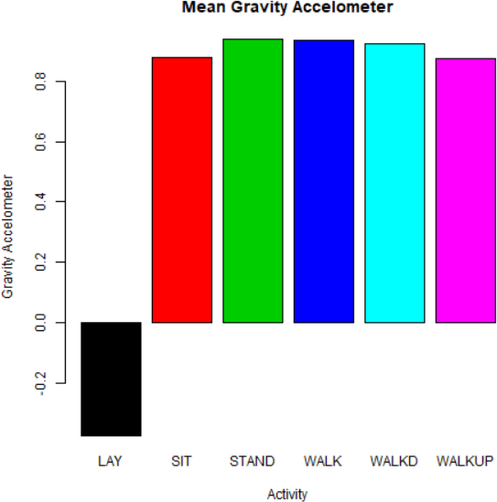

1. This graph shows that when readings are taken from a gyroscope body magnet the person is not at all lying, sitting or standing. Maximum chance is of the person to be in walking position.

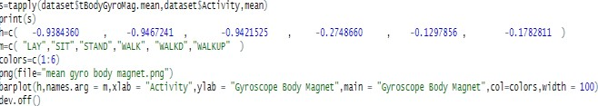

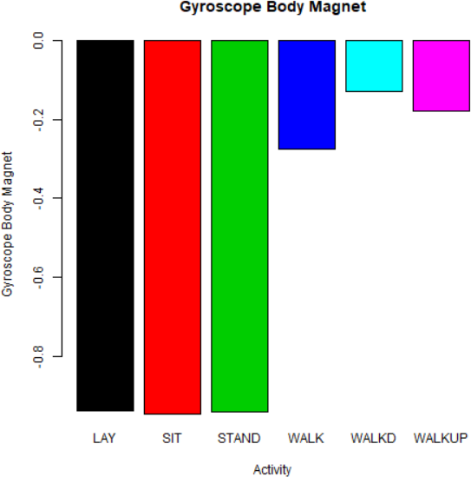

1. This graph shows that when the mean gyroscope is having a negative value the person is walking downstairs. While on the other hand, when the magnitude of the gyroscope is increasing positively,the person is walking upstrairs.

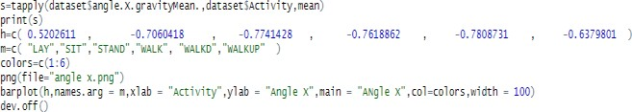

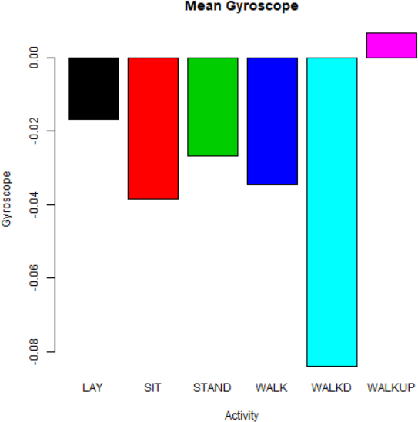

1. The graph represents the value of Gyroscope due to jerks which are sensed by the sensor. This graph depicts that the negative value of jerk is highest when the person is walking up and lowest when a person is walking down ,which indicated that the person while going downwards experience more jerk in the body and the gyro sensor.

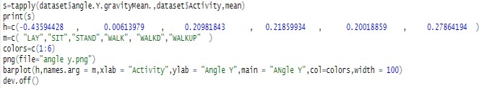

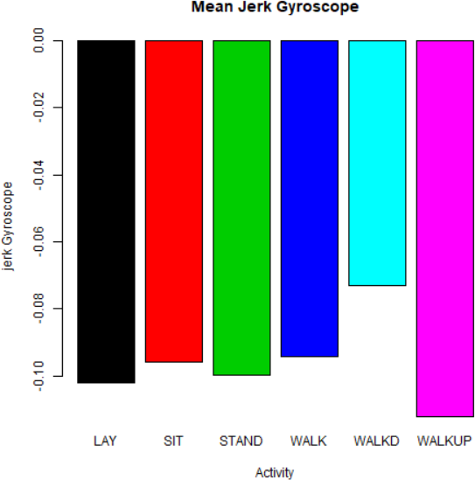12 This is the graphical representation of each activity and its density with respect to X and Y axis from the gravity.

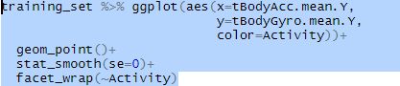

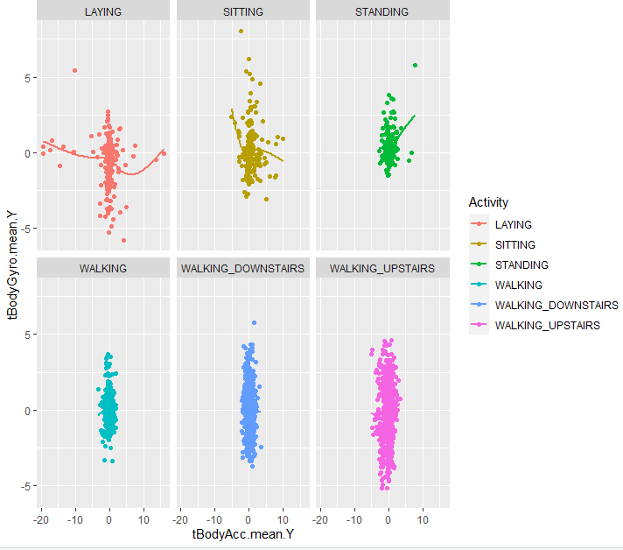

1. This graph is detecting the presence of body activity on the basis of energy levels of the body detected by the sensors. The high density of walking , walking upstairs and walking downstairs clearly depicts that the energy levels are highest while performing these activities. The negligible values of **Lying** (Red) and Sitting(yellow) concludes the low energy levels of the body while performing these two activities.

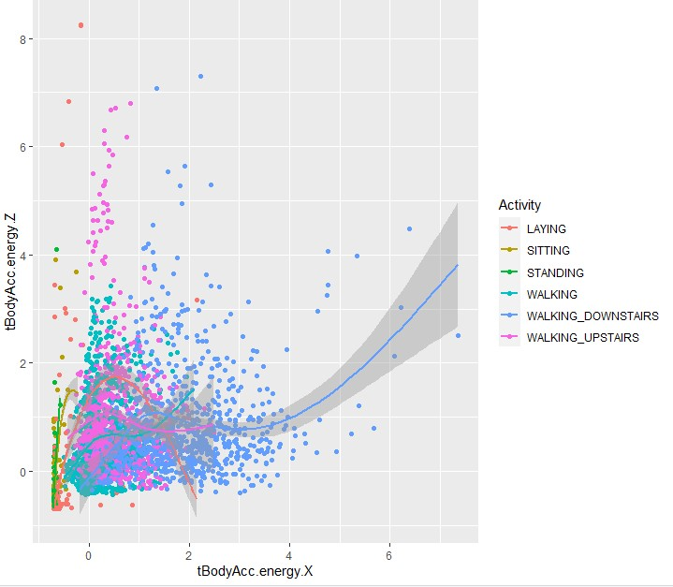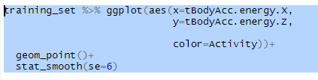

1. In the event that we investigate the diagram, we can see that each line on a normal, advances between a most extreme scope of 0.2–0.3 qualities. This is in fact the normal conduct as slight varieties can be credited to minor human blunders(errors).In this graph the mean gravity and time graph is visualized for 30 subjects(humans).

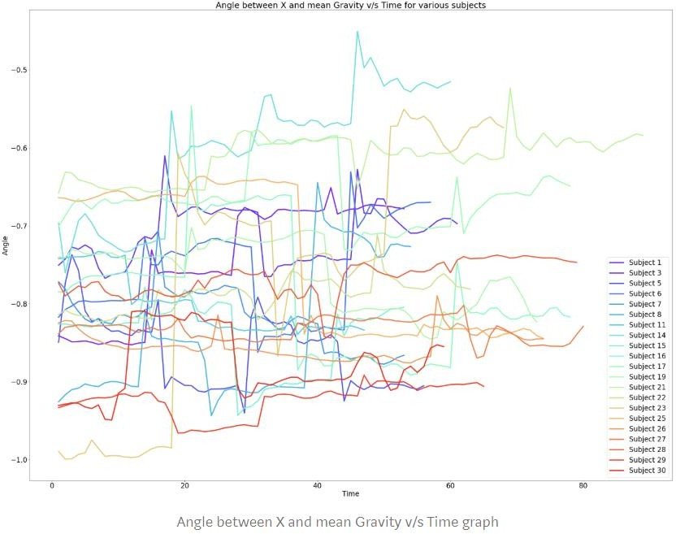

further used for measuring the heart rates, Blood pressure,etc. In the future scope,more actions and activities can be taken into consideration using more sensors and more sensor data.